Day Old Chicks (from Mt Healthy Hatcheries):
Rhode Island Reds (most popular)
Barred Plymouth Rocks (most popular)
Araucanas/Ameraucanas (most popular)
Babcock White Leghorns
Brown Leghorns
Golden Comets
White Plymouth Rocks
Black Austalorps
Production Reds
Cuckoo Marans
Speckled Sussex
Buff Orpingtons
Partridge Rocks
Jersey Black Giants
Golden Laced Wyandottes
Silver-Laced Wyandottes
Buckeyes
Light Brahmas
Buff Brahmas
Dark Brahmas
New Hampshires
Columbian Rock Cross
Red Cross
Black Sex Links
Welsummer
Amberlinks
Assorted Bantams
Cornish X Rock Cross (meat birds)
Freedom Rangers (meat birds)
Also
Orlopp Mammoth Bronze Turkeys
Broad Breasted White Turkeys
Artisan Gold Turkeys
White Pekin Ducks
Khaki Campbell Ducks
Indian Runners Ducks
Mallard Ducks
Rouen Ducks
French Guineas

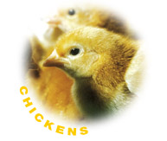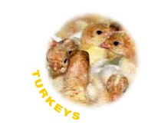

We have been ordering from Mt Healthy for the past 10 years with great success. Single chicks are $4.00 but we offer the same quantity pricing you would get if ordering direct from Mt Healthy, plus you do not pay shipping! By ordering your chicks in advance you guarantee that you will get the number and mix of chicks that you would like but we will have extras available. Mt Healthy has a 90% accuracy rate on sexed pullets.

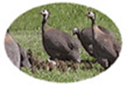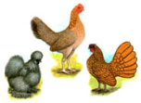

We also have examples of many of the available chickens living outside if you would like to ask us about them.

